
Document BRD
This specification outlines V Mobile’s business requirements for subscriber behaviour analysis in relation to a recently launched campaign.

Business Requirements Document
Subscriber Behaviour Analysis for Campaigns

PBT Academy
Issue 0.001, Author Control
July 2025
Copyright
Copyright © 2019 PBT Group (SA) (Pty) Ltd.)
All rights reserved. Company and product names are trademarks or registered trademarks of their respective companies

Contents
1. Project Introduction 3
1.1 Scope 3
1.2 Business Problem 3
1.2.1 Qualification Criteria 3
1.2.2 Assumptions 3
1.2.3 Business Rules 3
2. Project Solution 4
2.1 Data Analysis 4
2.1.1 Data Flow diagram 4
2.1.2 Solution Diagram 4
2.2 Data Preparation 4
2.3 Data Visualisation 4
2.3.1 Visualisation 4
2.4 Client Presentation 4
2.5 Technology 4

Project Introduction

Scope

Project Scope Statement

Project Name | VMobile Campaign Analysis
Description | VMobile’s Marketing team is running a campaign, but are unable to analyze the performance of their campaign. In order for the marketing team to determine the performance of their campaign, they require weekly reports which contain consolidated and filtered qualifying subscriber data from various source systems.
Deadline | 2 December 2025
Goal | Develop a system which will consolidate data and generate clear reports and visualizations, which will allow Marketing to gain insight to the impact of their campaign
Deliverables | - Generate a weekly report for Marketing.  - Create a visualization to interactively analyse the trends in data  - Present the solution to stakeholders
In-scope Items | - Write a script to create the MySQL database tables based on business requirements for the report.  - Write a Python/SQL script which extracts subscriber information from the three different subscriber systems.  - Write a Python/SQL script which combines all this subscriber information and loads it into the necessary tables.  - Write a Python/SQL script which generates a weekly report from the necessary tables.  - Create a visualization using Excel to analyse trends in data.  - Upload the solution and artifacts to a Github repository.  - Create a presentation and explain the solution to the necessary stakeholders.
Out of scope Items | - Future forecasting of campaign performance
Constraints | - Tight deadline – 4 December 2025  - Only 1 employee assigned to conducting the entire SDLC process for VMobile  - Limited access to the customer to (required to gain constant feedback throughout SDLC, to determine if the solution still aligns with their expectations).

Business Problem
VMobile’s Marketing team cannot effectively gauge the performance of their weekly campaign. This is because they lack a consolidated view of their subscriber activity, specifically the weekly count of subscribers who qualify for free minutes. This data gap prevents the marketing team from making strategic adjustments, which results in sub-par utilization of spending budgets and resources, ultimately hindering maximum customer engagement and overall campaign Return On Investment(ROI).

Qualification Criteria

Subscriber to earn free minutes | - Subscriber must generate revenue of R30 or more for the week
Master record calculation ( see graphic below ) | - If the customer exists in VMobile, then VMobile becomes the master record for that customer  - If the customer does not exist in VMobile, but exists in BlueMobile or Arrowmobile, compare the sim activation dates and set the master record as the record which has the latest sim activation date  - For ties, bluemobile takes priority over arrowmobile

Graphic for master record calculation
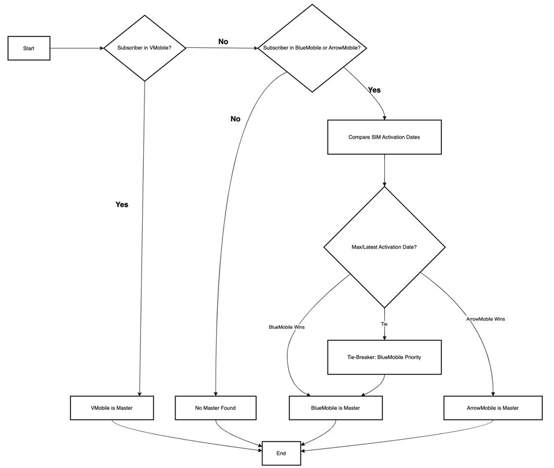

Assumptions
- All data received from the source systems is clean and accurate.
- All data received from the source systems is complete.
- The mediation source provides a weekly extract every Monday at 4am.
- The extract generated from the mediation source contains raw data for the past week.
- The 60 minutes free call that were done by the subscribers have been excluded from the data set provided by the source system.
- Revenue is generated only from voice calls and SMS’s.
- Column headings [‘Cell_Number’,’Cell’,’CellNo’] from the various source systems all represent cell phone numbers of subscribers.
- Column headings [‘Activate’,’SimDate’,’Sim_Activation_Date’] from the various source systems all represent SIM activation dates.
- Column heading [‘MSISDN’] from the usage report represents subscriber cell phone numbers.

Business Rules
- Subscriber must generate revenue of R30 or more to qualify for free minutes.
- Revenue can only be generated from SMS’s and voice calls.
- A subscriber can only qualify once per week.
- All clients will keep only one instance of a cell phone number.
- VMobile must be seen as the master and most trusted source record.
- If the subscriber does not exist in VMobile, but exists in either Bluemobile or Arrowmobile, refer to the qualification criteria for master record to then determine the master record.

Project Solution
The project solution consists of 3 phases, namely:

- Database schema setup and extraction
The process began with the MySQL database schema creation. I started off with creating 3 tables which mirrored the 3 CSV subscriber files (VMobile, Bluemobile, Arrowmobile). Extraction then involved using pandas to read the CSV files, extract the data, place it into a pandas dataframe, reformat the dataframe column names, and the load it into the 3 specific tables using the “tosql” method.

- Transformation and master record determination
This phase included implementing all the business rules specified. Logic was implemented to combine all subscribers into one single dataframe. From here, more logic and calculations were implemented to identify the master record for each subscriber. Thereafter, all the subscriber data was placed into a single combined MySQL table. However, this table still contained duplicate records. Another table was then created for the purpose of storing all subscriber information, but excluding duplicate records.

- Identifying the qualifying subscribers
This is the final loading step. It populates the qualifying subscribers table by joining the combined table(no duplicates) after calculating the revenue each customer made and checks whether they met the minimum threshold to qualify.

Data Analysis
The following was observed and realized throughout the project:

- Data from the CSV files was not completely clean, and therefore required formatting.
- Staging table columns had to be renamed in order to be consistent with the combined table column names.
- A special function had to be created to mark commas, and semi commas as delimiters in the CSV files, as the delimeters were inconsistent.
- Cell phone number formats had to be reformatted across all tables.
- Date formats had to be reformatted across all tables.

Data Flow diagram(assumptions)

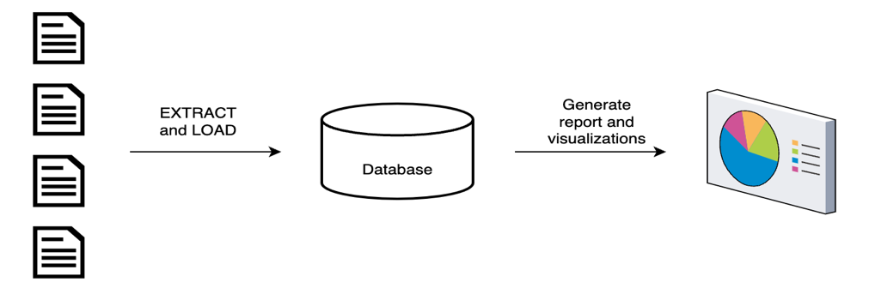

Solution Diagram

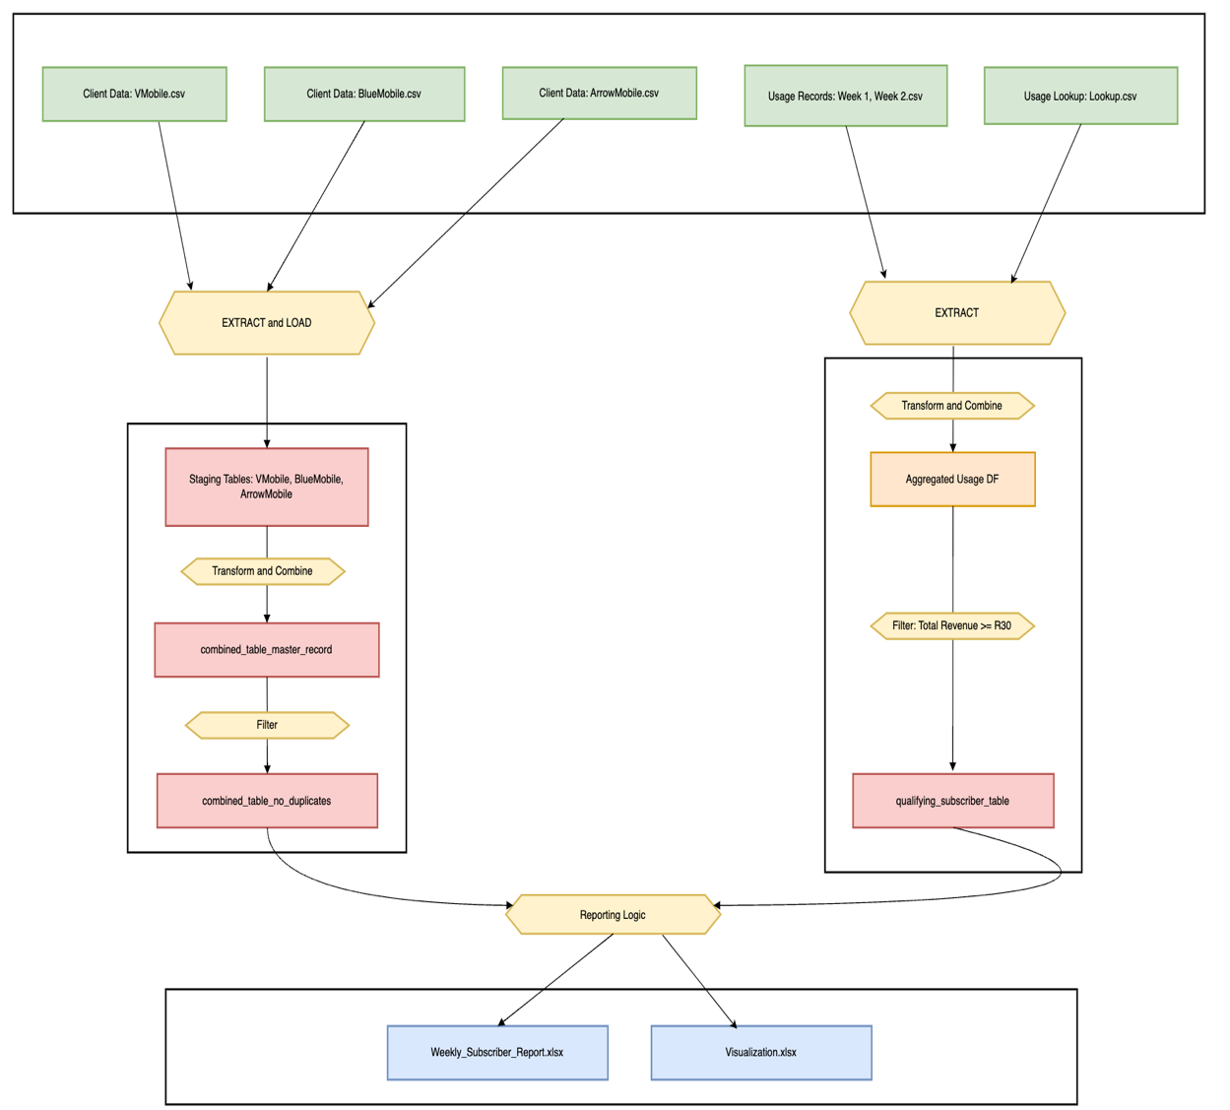

Data Preparation
Db_schema_creation.py
- contains the code to establish the database connection, database tables and database connection object
master_record_load.py
- contains the code to extract, transform and load all the data

Data Visualisation
The following visualisations will be created:

Report

A weekly report containing the following subscriber information:
- Name
- Surname
- Revenue generated
- Total SMS’s sent
- Total voice calls made
- Start and end dates of the records populated in the report
- Date the report was generated

Visualization
A visualization that will allow Marketing to analyse trends in data. The visualization should be able to answer the following analytical questions:
1) What trends are there in qualified subscriber numbers over time?
2) Which city/area has the most qualifying subscribers each week?
To meet the above mentioned visualization requirements, we require the following variables:
- Total subscriber count per week
- Total subscriber count per region, per week

Client Presentation
Order flow of the presentation:

1. Business context and problem statement
2. Project scope and deliverables
3. Explanation of technical architecture
4. Example of reports generated

Technology
The following technology was used for each stage of the project.

 | Data  Analysis | Data Preparation | Data Visualisation | Client  Presentation
MySQL Server | x | x
Python | x | x
PowerBI
PowerQuery
Excel |  |  | x
PowerPoint |  |  |  | x
Canva

